Application form for the competition ”Lidls Plastikinitiativ”
Please describe your business plan:
To give us a good understanding of your idea, please explain the points below to the best of your knowledge. This will ensure that you get around to all aspects of your idea while becoming aware of how far along you are in the process.
Contact information | Full Name  Address  E-mail  Phone number
Idea  (max 200 words) | Describe your idea and explain where in the waste pyramid it originates (see figure below)  What problem can the idea solve?  Why is the idea innovative? How does it differ from other ideas?
Environmental impact  (max 150 words) | What environmental impact does the idea have in a life cycle perspective?  What positive impact does the idea have throughout its life cycle?  What do you assess the environmental impact will be after resp. 1 and 5 years?
Risks | Is there an unintended negative environmental impact? Are there risks that your idea may solve a problem but at the same time cause new challenges for the environment?
Budget | What is the estimated budget to be able to carry out the idea?
Time plan | How far are you in the process of developing your idea?  What is the estimated time spent on implementing the idea?
Marketing/sales | How should your idea be sold/marketed?  Who is your target group?
Visualization | If you have a picture of a prototype or some other form of visualization of your idea, you can upload it here.

Send your application to Plastik@Lidl.dk. After 27.10.21 at 23:59 we will read all received applications and select the finalists. You will receive a response back whether you are in the competition or not. If you have any questions regarding the competition, you are welcome to send an email to CSR@lidl.dk.
Waste hierarchy:
The idea should be based on the waste hierarchy below. The waste hierarchy illustrates where it is most meaningful to take action in relation to the fight against unnecessary plastic. The upper level of the figure is the most preferred way of handling waste, whereas the lower layer is the least preferred. It is especially at levels 1, 2 and 3, we would like to see your idea take its origin.

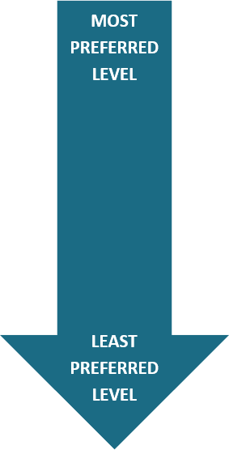
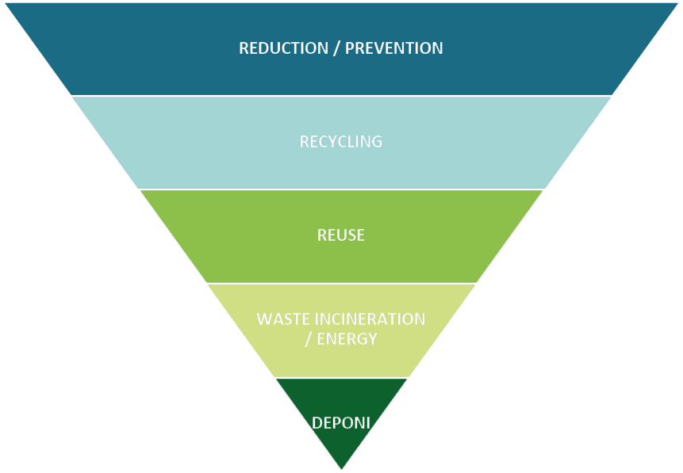

Environmental impact is defined as any change in the environment, whether negative or beneficial, as a result of a product, activity or service.

